ONEWAY ACC BY HAD
/STATISTICS DESCRIPTIVES HOMOGENEITY WELCH
/PLOT MEANS
/MISSING ANALYSIS.

Oneway

Notes
Output Created |  | 05-May-2019 23:31:56
Comments
Input | Active Dataset | DataSet0
Input | Filter | <none>
Input | Weight | <none>
Input | Split File | <none>
Input | N of Rows in Working Data File | 30
Missing Value Handling | Definition of Missing | User-defined missing values are treated as missing.
Missing Value Handling | Cases Used | Statistics for each analysis are based on cases with no missing data for any variable in the analysis.
Syntax |  | ONEWAY ACC BY HAD  /STATISTICS DESCRIPTIVES HOMOGENEITY WELCH  /PLOT MEANS  /MISSING ANALYSIS.
Resources | Processor Time | 00 00:00:00.156
Resources | Elapsed Time | 00 00:00:00.165

[DataSet0]

Descriptives
ACC
 | N | Mean | Std. Deviation | Std. Error
1-4 hours per day | 10 | 101.0000 | 23.30474 | 7.36961
4-8 hours per day | 6 | 94.8333 | 28.44234 | 11.61154
Less than an hour a day | 9 | 81.3333 | 16.97056 | 5.65685
More than 8 hours per day | 5 | 106.8000 | 35.50634 | 15.87892
Total | 30 | 94.8333 | 25.60722 | 4.67522

Descriptives
ACC
 | 95% Confidence Interval for Mean |  | Minimum | Maximum
 | Lower Bound | Upper Bound | Minimum | Maximum
1-4 hours per day | 84.3288 | 117.6712 | 71.00 | 124.00
4-8 hours per day | 64.9849 | 124.6817 | 57.00 | 128.00
Less than an hour a day | 68.2886 | 94.3781 | 50.00 | 100.00
More than 8 hours per day | 62.7131 | 150.8869 | 67.00 | 150.00
Total | 85.2714 | 104.3952 | 50.00 | 150.00

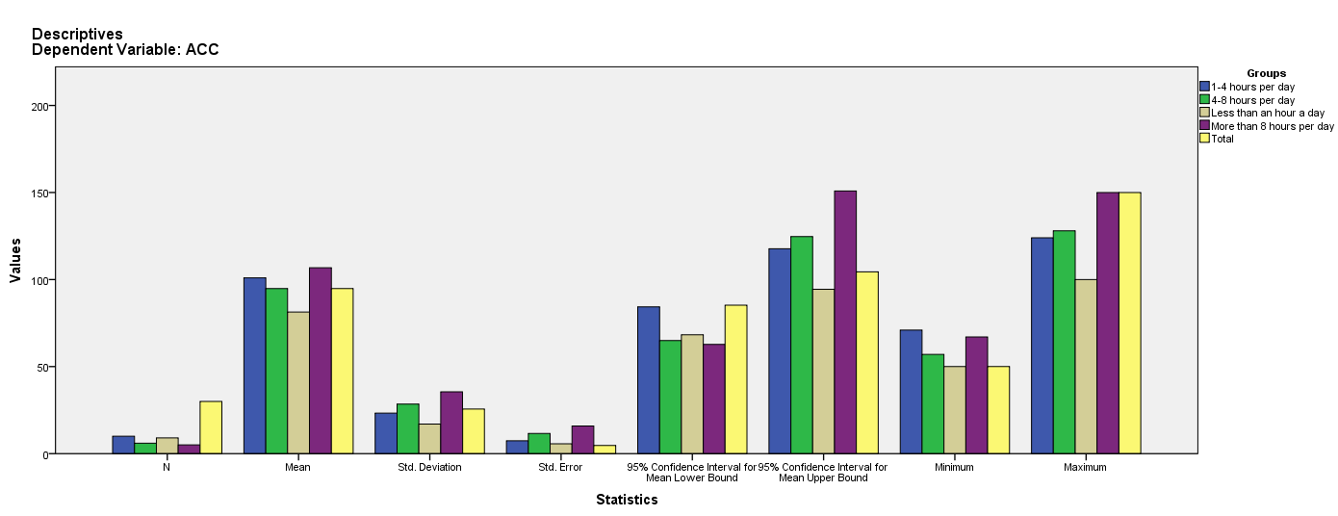

Test of Homogeneity of Variances
ACC
Levene Statistic | df1 | df2 | Sig.
2.806 | 3 | 26 | .059

ANOVA
ACC
 | Sum of Squares | df | Mean Square | F | Sig.
Between Groups | 2736.533 | 3 | 912.178 | 1.457 | .249
Within Groups | 16279.633 | 26 | 626.140
Total | 19016.167 | 29

Robust Tests of Equality of Means
ACC
 | Statisticª | df1 | df2 | Sig.
Welch | 1.738 | 3 | 10.943 | .217
a. Asymptotically F distributed.

Means Plots

